7.0.1 Editors - 3D View - Object mode - Object Context Menu
Detailed table of content 2
Object Context Menu 5
Object Context Menu - All objects 5
Copy Objects 5
Paste Objects 5
Duplicate Objects 5
Duplicate Linked 6
Rename active Item 8
Mirror 8
Snap 9
Parent 10
Move to Collection 11
Delete 12
Object specific - Mesh object 12
Shade Smooth 12
Shade Flat 12
Set Origin 12
Object specific - Curve object 13
Shade Smooth 13
Shade Flat 13
Extrude Size 13
Width Size 13
Convert to Mesh 13
Convert to Grease Pencil 14
Set Origin 14
Object specific - Surface object 14
Shade Smooth 14
Shade Flat 14
Object specific - Text object 15
Extrude Size 15
Width Size 15
Convert to Mesh 15
Convert to Grease Pencil 15
Set Origin 15
Object specific - Grease Pencil object 16
Covert to Path 16
Convert to Mesh 16
Convert to Polygon Curve 16
Set Origin 16
Object specific - Empty + Image object + Force Field 17
Empty Draw Size 17
Object specific - Camera object 17
Camera Lens Angle 17
DOF Distance 18
Object specific - Light object 18
Point light 18
Sun light 18
Spot light 19
Area light 19

Detailed table of content

Detailed table of content
Detailed table of content 2
Object Context Menu 5
Object Context Menu - All objects 5
Copy Objects 5
Paste Objects 5
Last Operator Paste Selection from Buffer 5
Select 5
Active Collection 5
Duplicate Objects 5
Last Operator Duplicate 6
Duplicate Objects 6
Linked 6
Move X , Y , Z 6
Orientation 6
Proportional editing 6
Proportional Falloff 6
Proportional Size 6
Connected 6
Projected(2D) 6
Duplicate Linked 6
Last Operator Duplicate Linked 7
Duplicate Objects 7
Linked 7
Move X, Y, Z 8
Orientation 8
Proportional editing 8
Proportional Falloff 8
Proportional Size 8
Connected 8
Projected(2D) 8
Rename active Item 8
Mirror 8
Interactive Mirror 8
Usage: 8
X Y Z Global 9
X Y Z Local 9
Last Operator Mirror 9
Orientation 9
Proportional editing 9
Proportional Falloff 9
Proportional Size 9
Connected 9
Projected(2D) 9
Snap 9
Selection to Cursor 9
Selection to Cursor(Keep Offset) 9
Last operator Snap Selection to Cursor 9
Offset 9
Selection to Active 9
Selection to Grid 10
Cursor to Selected 10
Cursor to World Origin 10
Cursor to Active 10
Cursor to Grid 10
Parent 10
Object 10
Object ( Keep Transform) 10
Armature Deform 11
With empty Groups 11
With Envelope Weights 11
With automatic Weights 11
Bone 11
Bone Relative 11
Move to Collection 11
Last Operator Move to Collection 11
Name 11
Insert Keyframe 11
Delete 12
Object specific - Mesh object 12
Shade Smooth 12
Shade Flat 12
Set Origin 12
Geometry to Origin 12
Origin to Geometry 12
Origin to 3D cursor 12
Origin to Center of Mass(Surface) 12
Origin to Center of Mass(Volume) 12
Last Operator Set Origin 12
Type 13
Center 13
Object specific - Curve object 13
Shade Smooth 13
Shade Flat 13
Extrude Size 13
Width Size 13
Convert to Mesh 13
Convert to Grease Pencil 14
Set Origin 14
Geometry to Origin 14
Origin to Geometry 14
Origin to 3D cursor 14
Origin to Center of Mass(Surface) 14
Origin to Center of Mass(Volume) 14
Last Operator Set Origin 14
Type 14
Center 14
Object specific - Surface object 14
Shade Smooth 14
Shade Flat 14
Object specific - Text object 15
Extrude Size 15
Width Size 15
Convert to Mesh 15
Convert to Grease Pencil 15
Set Origin 15
Geometry to Origin 15
Origin to Geometry 15
Origin to 3D cursor 16
Origin to Center of Mass(Surface) 16
Origin to Center of Mass(Volume) 16
Last Operator Set Origin 16
Type 16
Center 16
Object specific - Grease Pencil object 16
Covert to Path 16
Convert to Mesh 16
Convert to Polygon Curve 16
Set Origin 16
Geometry to Origin 16
Origin to Geometry 16
Origin to 3D cursor 16
Origin to Center of Mass(Surface) 17
Origin to Center of Mass(Volume) 17
Last Operator Set Origin 17
Type 17
Center 17
Object specific - Empty + Image object + Force Field 17
Empty Draw Size 17
Object specific - Camera object 17
Camera Lens Angle 17
DOF Distance 18
Object specific - Light object 18
Power 18
Point light 18
Radius 18
Sun light 18
Angle 18
Spot light 19
Radius 19
Spot Size 19
Spot Blend 19
Area light 19
Size X / Size Y 19

Object Context Menu

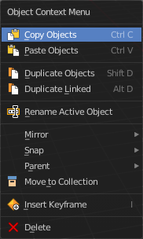
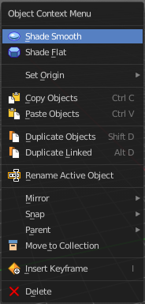
Call this menu with double right click in the 3D viewport. You need to be in Object mode.

The Object Context Menu appears in object mode with all object types. Even without any object in the scene.

The content of this menu differs. With a mesh object you have for example smoothing available too. And with a curve object the convert options.

Object Context Menu - All objects

This content shows with all object types.

Copy Objects
Copies the selected object(s).

Paste Objects
Pastes copied object(s).

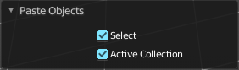
Last Operator Paste Selection from Buffer

Select
Select pasted object(s).

Active Collection
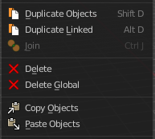
Put the pasted objects into the active collection.

Duplicate Objects
Duplicates selected objects. The copy is completely independent. All containing data gets duplicated too. And you can edit the object instances completely independent. then.
You are automatically in grab mode, and so you can easily move the object out of position. Which is sometimes wanted, since you can position the duplicate then. But sometimes this is unwanted. A right click after releasing the mouse lets the object snap back into its creation position.
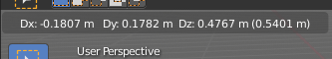
When you drag the duplicate around you will see the position values in the header.

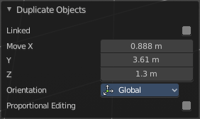
Last Operator Duplicate

Duplicate Objects

Linked
With this option ticked the duplication happens with linked data.

Move X , Y , Z
The Position of the duplicated object.

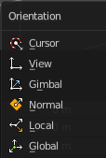
Orientation
Orientation is a drop-down box wChoose the type of orientation for the duplicate action.

Proportional editing

Enables proportional editing. Activating proportional editing reveals further settings.

Proportional Falloff
Adjust the falloff methods.

Proportional Size
See and adjust the falloff radius.

Connected
The proportional falloff gets calculated for connected parts only.

Projected(2D)
The proportional falloff gets calculated in the screen space. Depth doesn't play a role. When it's in the radius, then it gets calculated.

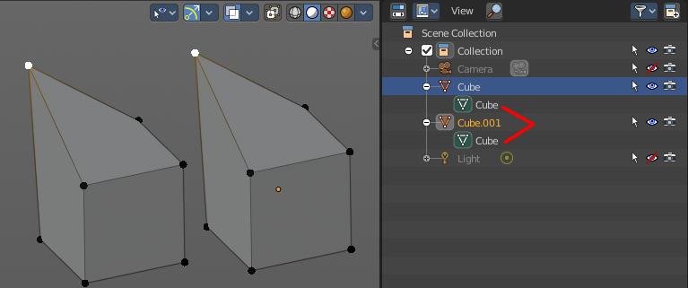
Duplicate Linked
Duplicates selected objects. The instance has its own transforms. But the duplicate shares some data with the first instance. This means when you for example edit the mesh of one of the instances, then the other instance gets modified too. As you can see this in the screenshot. Here you can also see that the mesh name is the same. The object name is different though.

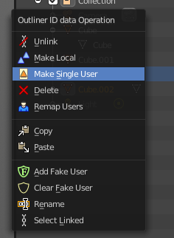
If you want to make changes to an object in the new linked duplicate independently of the original object, then you will have to manually make the object a “single-user” . This can be done for example in the Outliner, in the right click menu of the object. (Currently broken). Or in the Object menu. Choose what attached data you want to make single user.
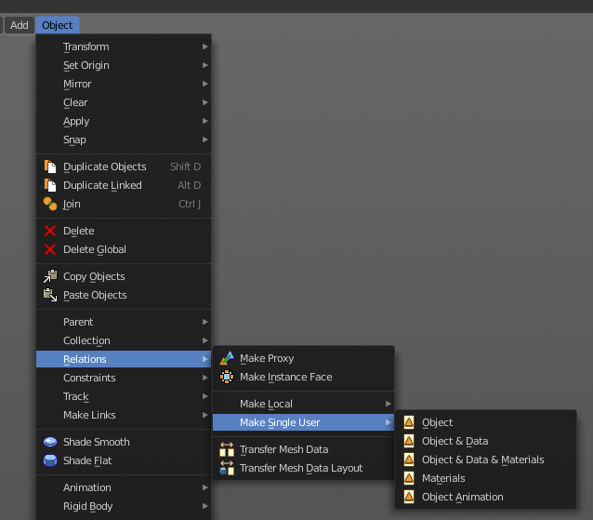

When you duplicate an object, then you are automatically in grab mode. And so you can easily move the object out of position. which is sometimes wanted, since you can position the duplicate then. But sometimes this is unwanted. A right click after releasing the mouse lets the object snap back into its creation position.
Duplicate linked instances the object data.
Explanation: Each Bforartists object type (mesh, lamp, curve, camera etc.) is composed from two parts: an Object and Object Data (sometimes abbreviated to ObData):
Object - Holds information about the position, rotation and size of a particular element.
Object Data - Holds everything else. For example. Meshes stores geometry, material lists, vertex groups, etc. . Cameras stores focal length, depth of field, sensor size, etc. .
Each object has a link to its associated object-data, and a single object-data, like a material, may be shared by many objects.

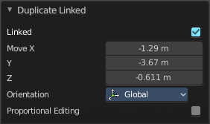
Last Operator Duplicate Linked

Duplicate Objects

Linked
With this option ticked the duplication happens with linked data.

Move X, Y, Z
The Position of the duplicated object.

Orientation
Orientation is a drop-down box wChoose the type of orientation for the duplicate action.

Proportional editing
Enables proportional editing. Activating proportional editing reveals further settings.

Proportional Falloff
Adjust the falloff methods.

Proportional Size
See and adjust the falloff radius.

Connected
The proportional falloff gets calculated for connected parts only.

Projected(2D)
The proportional falloff gets calculated in the screen space. Depth doesn't play a role. When it's in the radius, then it gets calculated.

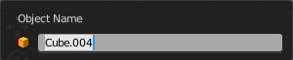
Rename active Item
Allows you to rename the currently active item. A rename dialog will pop up where you can type in a new name for the current item. You can have more than one item selected. Just the active item gets renamed.
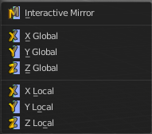

Mirror
Mirrors the selection.

Interactive Mirror
Mirrors the selection.

Usage:
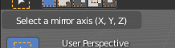
Activate the tool. In the header you will now see further instructions. Which is: type in the axis at which you want to mirror. Interactive mirroring starts in Global space. You can change the orientation in the last operator.

X Y Z Global
Mirrors along the global axis.

X Y Z Local
Mirrors along the object axis.

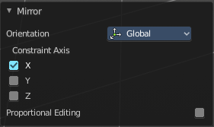

Last Operator Mirror

Orientation
Choose the orientation in which the transform should happen.

Proportional editing
Enables proportional editing. Activating proportional editing reveals further settings.

Proportional Falloff
Adjust the falloff methods.

Proportional Size
See and adjust the falloff radius.

Connected
The proportional falloff gets calculated for connected parts only.

Projected(2D)
The proportional falloff gets calculated in the screen space. Depth doesn't play a role. When it's in the radius, then it gets calculated.

Snap

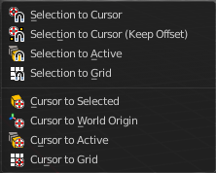
Selection to Cursor
Snaps the currently selected object(s) to the cursor location.

Selection to Cursor(Keep Offset)
Snaps the currently selected object(s) to the cursor location, but keeps the offset of the selected objects to each other. Means the center of the current selection goes to cursor position. Not every individual object.

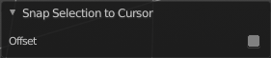
Last operator Snap Selection to Cursor

Offset
Keep the offset of the selected objects to each other.

Selection to Active
Snaps the currently selected object(s) to the active object.

Selection to Grid
Snaps the currently selected object(s) to the nearest grid point.

Cursor to Selected
Moves the cursor to the center of the selected object(s).

Cursor to World Origin
Moves the cursor to the world origin.

Cursor to Active
Moves the cursor to the center of the active object.

Cursor to Grid
Moves the cursor to the nearest grid point.

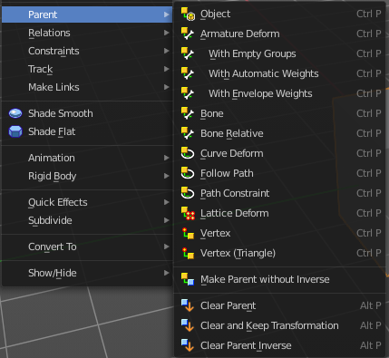
Parent
The parent menu provides you with all parenting methods at object level.

To use parenting you first have to select the source object, hold down shift, then select the target object so that both are selected. This also works in the outliner (here you can also simply hold down shift and drag the source object at the target object to make it a child). The source object becomes the child object then.

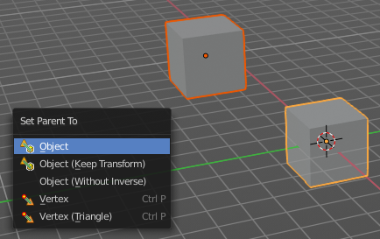
The methods are object type dependant. The armature methods requires to have a mesh and a armature. The path methods a curve. The available methods for the current selection can also be found out by pressing the hotkey ctrl P. This calls the parenting menu with just the available methods.

Object
Sets the parent to selected object.

Object ( Keep Transform)
Sets the parent to selected object, but applies all transform before the operation.

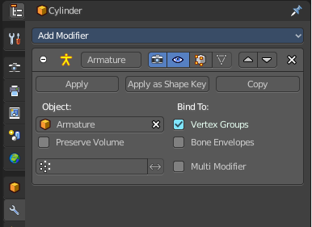
Armature parenting creates a armature modifier at the mesh.

Armature Deform
Sets the parent to selected Armature.

With empty Groups
Sets the parent to selected Armature, using empty groups.

With Envelope Weights
Sets the parent to selected Armature, using envelope weights

With automatic Weights
Sets the parent to selected Armature, with automatic weights.

Bone
Sets the parent absolute to selected Bone.

Bone Relative
Sets the parent relative to selected Bone.

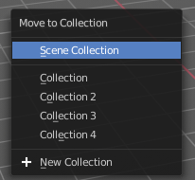
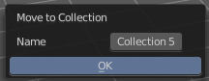
Move to Collection
Moves the selected object to a collection. The object is removed from the collection it was in.
By clicking at this menu item a popup will appear wChoose the new collection. Allows also to create a new collection. Once done, the object will be moved to this new created collection.

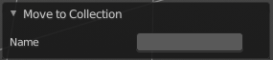
Last Operator Move to Collection

Name
Set a name for your new collection. When you haven't created a new collection, then this name stays blank.

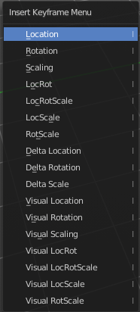
Insert Keyframe
Calls the Insert Keyframe menu
The keying set defines what kind of key frames gets recorded. When you start with an
animation, and your object does not have a keying set yet, then you will be prompted with a menu wChoose the proper keying set. The Insert Keyframe menu.

Note that this just adds a keying set to the current keyframe. And not to the whole object. That's why the keying set menu down right stays empty when you add a keyframe this way.

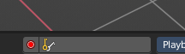

Delete
Deletes the selected object(s).

Object specific - Mesh object

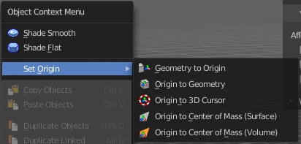
Shade Smooth
Sets the shading for the object to smooth. Flat means that every face of the object shows facettet, with a sharp edge. Smooth means that the edges are not longer to see.
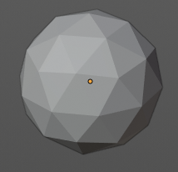
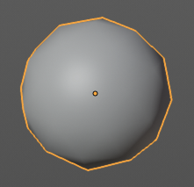

Shade Flat
Sets the shading for the object to flat. Flat means that every face of the object shows facettet, with a sharp edge. Smooth means that the edges are not longer to see.

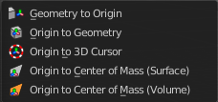
Set Origin

Geometry to Origin
Sets the geometry to origin.

Origin to Geometry
Sets the origin to geometry.

Origin to 3D cursor
Sets the origin to the 3D cursor.

Origin to Center of Mass(Surface)
Sets the origin to the center of mass, calculating it from the center of the surface area.

Origin to Center of Mass(Volume)
Sets the origin to the center of mass, calculating from the center of the Volume. It must be manifold geometry with consistent normals.

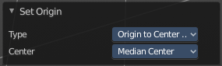
Last Operator Set Origin
The last operator is the same for all set origin methods.

Type
Choose the method again.

Center
Use the median center or the bounds center for calculation.

Object specific - Curve object

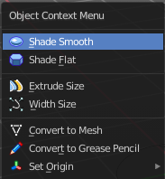
Shade Smooth
Sets the shading for the object to smooth. Flat means that every face of the object shows facettet, with a sharp edge. Smooth means that the edges are not longer to see.

Shade Flat
Sets the shading for the object to flat. Flat means that every face of the object shows facettet, with a sharp edge. Smooth means that the edges are not longer to see.

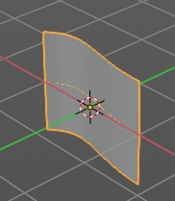
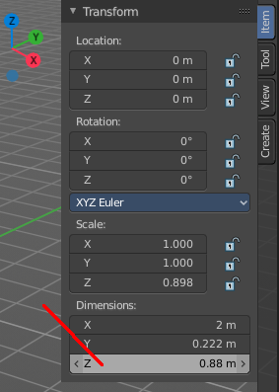
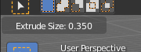
Extrude Size
Extrudes a surface out of a curve or text object.

In the header you can see the height of the extrusion. In the Transform panel in the sidebar you can adjust this height also afterwards. The Z value.

Width Size
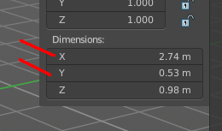
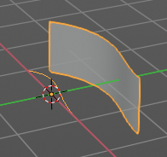
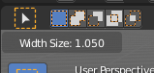
Width size is just of interest when you have a extruded surface at the curve. It scales the surface size in x and z direction.

Convert to Mesh
Converts a selected Curve to a Mesh Object.

Convert to Grease Pencil
Converts a selected curve to a grease pencil stroke.

Set Origin

Geometry to Origin
Sets the geometry to origin.

Origin to Geometry
Sets the origin to geometry.

Origin to 3D cursor
Sets the origin to the 3D cursor.

Origin to Center of Mass(Surface)
Sets the origin to the center of mass, calculating it from the center of the surface area.

Origin to Center of Mass(Volume)
Sets the origin to the center of mass, calculating from the center of the Volume. It must be manifold geometry with consistent normals.

Last Operator Set Origin
The last operator is the same for all set origin methods.

Type
Choose the method again.

Center
Use the median center or the bounds center for calculation.

Object specific - Surface object

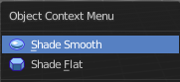
Shade Smooth
Sets the shading for the object to smooth. Flat means that every face of the object shows facettet, with a sharp edge. Smooth means that the edges are not longer to see.

Shade Flat
Sets the shading for the object to flat. Flat means that every face of the object shows facettet, with a sharp edge. Smooth means that the edges are not longer to see.

Object specific - Text object

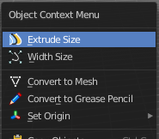

Extrude Size
Extrudes a surface out of a curve or text object.
In the header you can see the height of the extrusion. In the Transform panel in the sidebar you can adjust this height also afterwards. The Z value.

Width Size
Width size is just of interest when you have a extruded surface at the curve. It scales the surface size in x and z direction.

Convert to Mesh
Converts a selected Text to a Mesh Object.

Convert to Grease Pencil
Converts a selected Text to a grease pencil stroke.

Set Origin

Geometry to Origin
Sets the geometry to origin.

Origin to Geometry
Sets the origin to geometry.

Origin to 3D cursor
Sets the origin to the 3D cursor.

Origin to Center of Mass(Surface)
Sets the origin to the center of mass, calculating it from the center of the surface area.

Origin to Center of Mass(Volume)
Sets the origin to the center of mass, calculating from the center of the Volume. It must be manifold geometry with consistent normals.

Last Operator Set Origin
The last operator is the same for all set origin methods.

Type
Choose the method again.

Center
Use the median center or the bounds center for calculation.

Object specific - Grease Pencil object
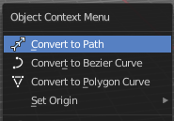

Covert to Path
Converts a selected Grease Pencil stroke to a new curve object of type Bezier Curve.

Convert to Mesh
Converts a selected Grease Pencil stroke to a Mesh Object.

Convert to Polygon Curve
Converts a selected Grease Pencil stroke to a new curve object of type Polygon.

Set Origin

Geometry to Origin
Sets the geometry to origin.

Origin to Geometry
Sets the origin to geometry.

Origin to 3D cursor
Sets the origin to the 3D cursor.

Origin to Center of Mass(Surface)
Sets the origin to the center of mass, calculating it from the center of the surface area.

Origin to Center of Mass(Volume)
Sets the origin to the center of mass, calculating from the center of the Volume. It must be manifold geometry with consistent normals.

Last Operator Set Origin
The last operator is the same for all set origin methods.

Type
Choose the method again.

Center
Use the median center or the bounds center for calculation.

Object specific - Empty + Image object + Force Field
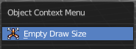
The Image object types is a special kind of an empty. Same for the Force Field. So they have the same entry in the context menu.

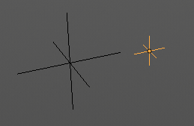
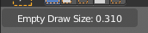
Empty Draw Size
Scale the size of the empty in the viewport.
Note, this value does not show elsewhere. And there is no way to reset it to the default size except to scale it again with Empty Draw Size. The value in the header will help you.

Object specific - Camera object
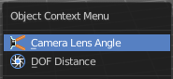

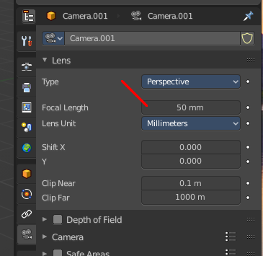
Camera Lens Angle
Changes the focal length of the camera. You can adjust it afterwards in the properties editor.
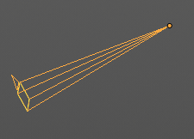

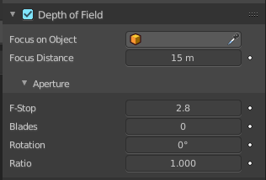
DOF Distance
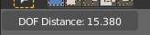
Changes the focus distance for depth of field. You can adjust it afterwards in the properties editor. The values in the depth of field are not as exact as the dof distance values though.

Object specific - Light object

Each light type has its own settings. Power is the same in all. When you adjust the values then you will see a string with the values in the header.

Power
Light energy adjusts the power of the light.

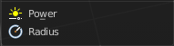
Point light

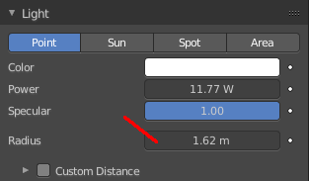
Radius
Adjust the radius of the point light.


Sun light

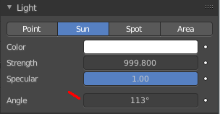
Angle
Adjust the angle of the sun light. Note that the value in the header is in radians, while the value in the panel is in degrees.

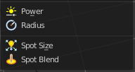
Spot light

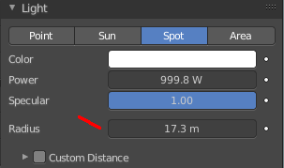
Radius
Adjust the radius of the spot light.

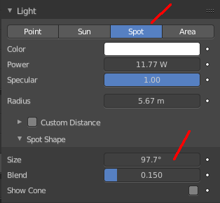
Spot Size
Adjust the angle of the spotlight beam. Note that the value in the header is in radians, while the value in the panel is in degrees.

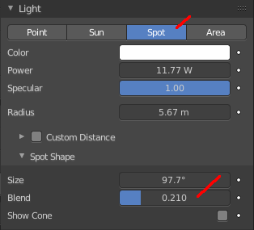
Spot Blend
Adjust softness of the spotlight edge.

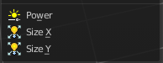
Area light

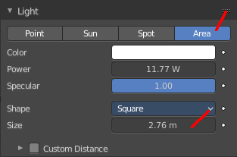
Size X / Size Y
Area light only.
Scale the size of the area light. Size Y appears with Shape Rectangle.

